Project Design Phase-II
Data Flow Diagram & User Stories

Date | 18 June 2026
Team ID
Project Name | Online Complaint Registration
Maximum Marks | 4 Marks

Data Flow Diagrams:
A Data Flow Diagram (DFD) is a traditional visual representation of the information flows within a system. A neat and clear DFD can depict the right amount of the system requirement graphically. It shows how data enters and leaves the system, what changes the information, and where data is stored.
System and Data flow

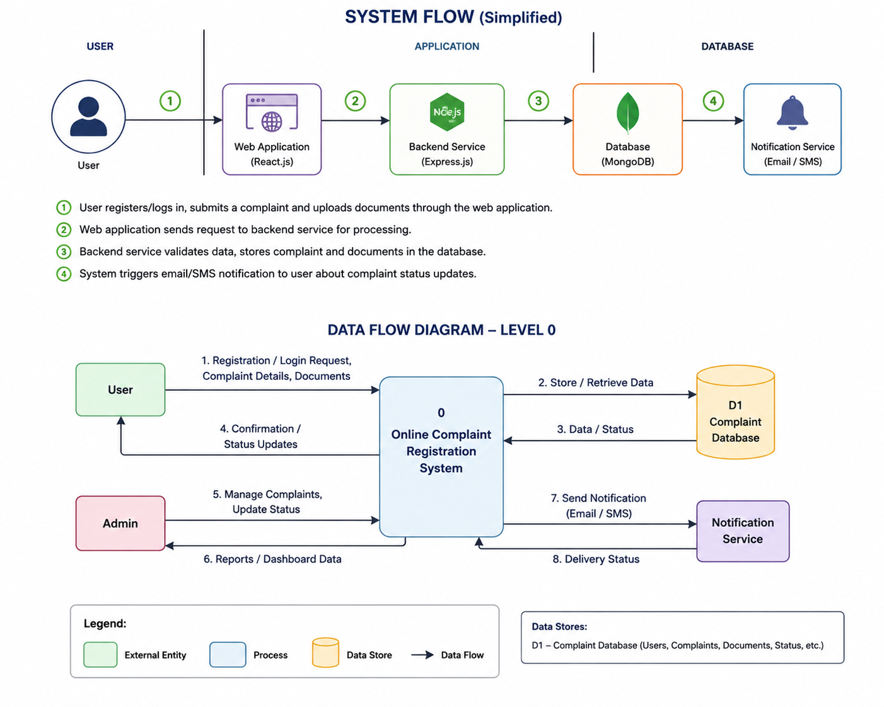

User Stories
Use the below template to list all the user stories for the product.
User Type | Functional Requirement (Epic) | User Story Number | User Story / Task | Acceptance Criteria | Priority | Release
Customer (Web/Mobile User) | Registration | USN-1 | As a user, I can register for the application by entering my name, email, password, and confirming my password. | User account is created successfully and user can access dashboard | High | Sprint-1
Customer (Web/Mobile User) | Registration | USN-2 | As a user, I will receive confirmation email once I have registered for the application. | User receives email and confirms account successfully | High | Sprint-1
Customer (Web/Mobile User) | Registration | USN-3 | As a user, I can register/login using social authentication. | User can access dashboard through social login | Low | Sprint-2
Customer (Web/Mobile User) | Login | USN-4 | As a user, I can log into the application using email and password. | User is authenticated and redirected to dashboard | High | Sprint-1
Customer (Web/Mobile User) | Dashboard | USN-5 | As a user, I can view my dashboard after login. | Dashboard displays user details and complaint options | Medium | Sprint-1
Customer (Web/Mobile User) | Complaint Registration | USN-6 | As a user, I can submit a complaint by entering complaint details. | Complaint is stored successfully in database | High | Sprint-2
Customer (Web/Mobile User) | Document Upload | USN-7 | As a user, I can upload documents/images as complaint proof. | Files are uploaded and attached to complaint | Medium | Sprint-2
Customer (Web/Mobile User) | Complaint Tracking | USN-8 | As a user, I can track my complaint status. | Current complaint status is displayed correctly | High | Sprint-2
Customer Care Executive | Complaint Management | USN-9 | As an executive, I can view assigned complaints and update progress. | Complaint status can be updated successfully | High | Sprint-3
Customer Care Executive | Communication | USN-10 | As an executive, I can communicate with users regarding complaints. | User receives required updates/messages | Medium | Sprint-3
Administrator | Admin Dashboard | USN-11 | As an administrator, I can view all users and complaints. | Admin dashboard shows complete complaint details | High | Sprint-3
Administrator | User Management | USN-12 | As an administrator, I can manage users and complaint records. | Admin can edit, update, or remove records | Medium | Sprint-4
Administrator | Reports | USN-13 | As an administrator, I can generate complaint reports. | Reports are generated successfully | Low

